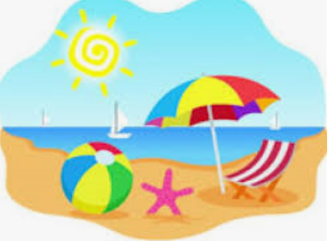Learning Plan for May 25th – 29th 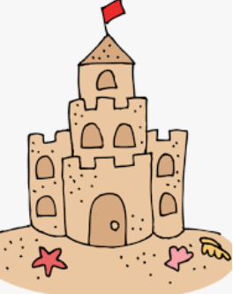
 | Monday | Tuesday | Wednesday | Thursday | Friday
Reading  15 minutes a day | Read a book at home OR Login and read a new book on Raz-Kids.  Practice building and reading CVC words on starfall.com. | Read a book at home OR Login and read a new book on Raz-Kids.  Practice building and reading CVC words on starfall.com. | Read a book at home OR Login and read a new book on Raz-Kids.  Join the TEAMS Meeting with Mrs. Matheson and listen to her read a story. | Read a book at home OR Login and read a new book on Raz-Kids.  Join the TEAMS Meeting with Mrs. Higgins and listen to her read a story. | Read a book at home OR Login and read a new book on Raz-Kids.  Join the TEAMS Meeting with Mrs. Magee and listen to her read a story.
Writing  15 minutes a day | Write a sentence (or more) about what you like to do in the summer. Draw a picture to match.  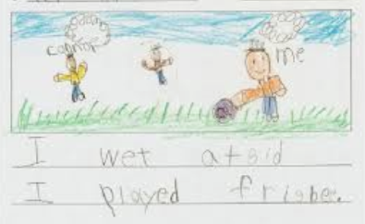  Example: “I went outside. I played frisbee.” | Make sight words using magnetic letters.  (Or rainbow write words with markers or crayons).  a, and, at, he, in, is, it, like, me, my, play, see, she, that, the, to, was  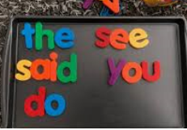 | Write a sentence (or more) about your favourite memory from this school year.  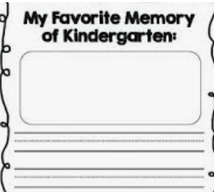 | Gather some sand from outside and put it in a container or on a pan. Use a stick or your finger to spell sight words or letters in the sand.  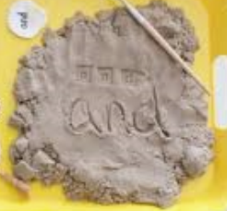 | Make a list of things you might see or do in the summer. (Encourage your child to stretch out the word slowly and print the sounds they hear).  bukit = bucket  snd = sand  swm = swim  bech = beach  butrfli = butterfly
Math  15 minutes a day | Counting  Use a deck of cards and any counters you have (cheerios, buttons, macaroni, etc.) to represent numbers. Flip over a card and count out that many counters.  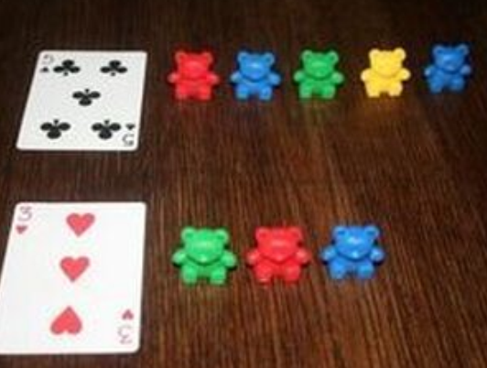 | Number Recognition  Play Number BINGO on abcya.com.  -OR-  Using a deck of cards play Go-Fish with a family member.  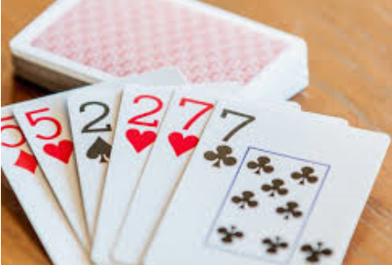 | Subitizing  Listen to Jack Hartman’s Subitizing Song on youtube.  -OR-  Roll a die and name the number or dots without counting.  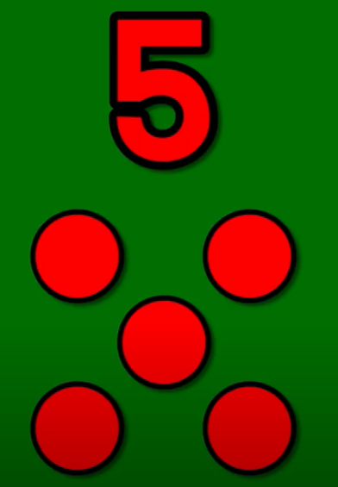 | Patterning  Use marshmallows like stamps. Dip them in paint and make patterns. Try to make these patterns: AB, ABC, AAB, ABB  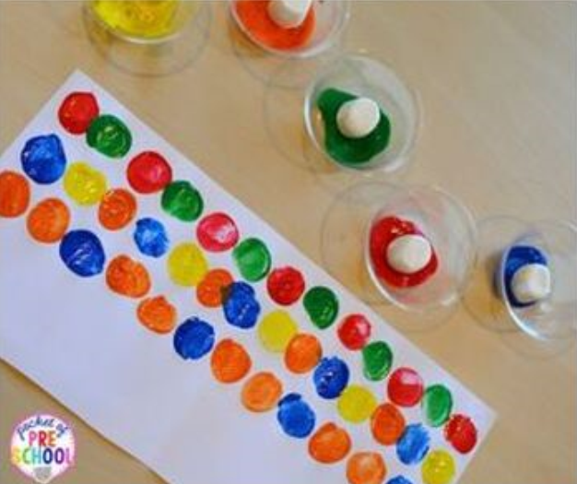 | Measurement  Make several different length playdoh snakes. Order your snakes from shortest to longest.  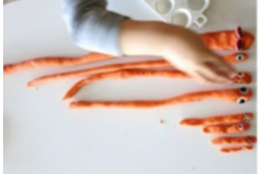
Other  15 minutes a day | Movement  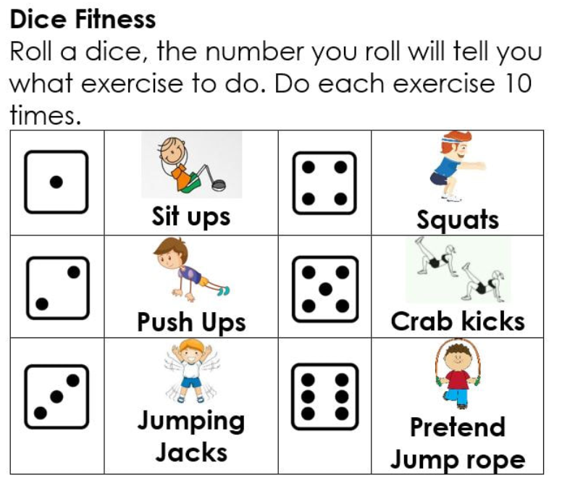 | Art  Learn how to draw a sand castle on arthub.  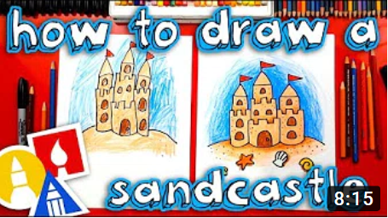 | You & Your World  Watch this video to learn how to grow your own plants.  -OR-  Plant your own seeds using a cup, some soil, and water. Remember to place your cup in the sunlight and water it everyday. | S.T.E.A.M  Make a beach using paper, lego, or play dough and take your mini teachers on a beach adventure.  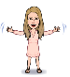  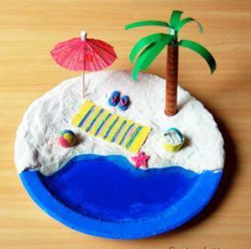 | French  Learn how to say new words in French by watching this video.  