Learning Plan for June 8th – June 12th
 | Monday |  | Tuesday |  | Wednesday |  | Thursday |  | Friday
Reading  15 minutes a day | Read a book at home OR Login and read a new book on Raz-Kids.  Go camping with Topsy and Tim |  | Read a book at home OR Login and read a new book on Raz-Kids.  Practice your letters at the Letter Dance Party on Starfall.com! |  | Read a book at home OR Login and read a new book on Raz-Kids.  Join the TEAMS Meeting with Mrs. Matheson and listen to her read a story. |  | Read a book at home OR Login and read a new book on Raz-Kids.  Join the TEAMS Meeting with Mrs. Higgins and listen to her read a story. |  | Read a book at home OR Login and read a new book on Raz-Kids.  Join the TEAMS Meeting with Mrs. Magee and listen to her read a story.
Writing  15 minutes a day | Write a sentence (or more) about what you did this weekend. Draw and label a picture to match.  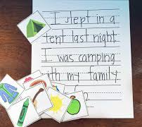 |  | Write some letters or simple words on the sidewalk with chalk. Soak a sponge in water and toss it on a letter or word. Then read the word you hit! How many can you get?  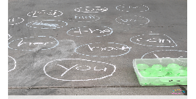 |  | Play a card game with a family member or friend. Use your flashcards to play a guessing game. Flip over a card. The first person to say the letter name and make the sound wins the card! Take turns flipping the cards and see how many you can guess! |  | Build sight words using magnetic letters, legos or beans. Then write the words using your white board markers.  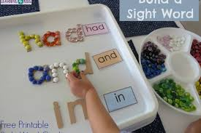  a, and, at, he, in, is, it, like, me, my, play, see, she, that, the, to, was |  | Make a list of all your favourite ice cream flavours. Stretch out the sounds in each word to do your best spelling!  Examples:  Fer= Fire  Mshmaloos= Marshmallows  Swming= Swimming  Fshing= Fishing
Math  15 minutes a day | Counting  Take your deck of cards and put the numbers in order for each suit. Which colour or suit gets all their numbers to10 first?!  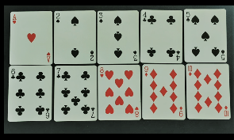 |  | Number Recognition  Listen to I Spy numbers  -OR-  What numbers can you find around your house?  (on electronics, clocks, flyers, toys etc.) 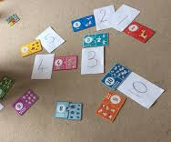 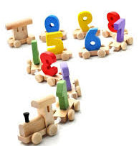 |  | Subitizing  Listen to Subitize Rock  -OR-  Collect a variety of leaves. Put them in a bucket and reach in to grab a handful. Try to subitize as quick as you can! |  | Patterning  Draw or use Play-Doh to make leaf patterns. How many different patterns can you create? Try to make these patterns:  AB, ABC, AAB, ABB  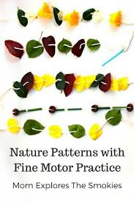 |  | Measurement  Using the sticks you collected from outside, put them in order from smallest to biggest.  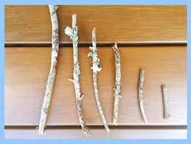
Other  15 minutes a day | Movement  Go on a camping dance party  -OR-  Have a dance party and bring your mini-teachers along to share in the fun! | Art  Learn how to draw a campfire on ArtHub!  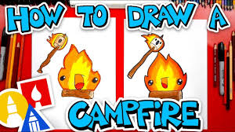 |  | You & Your World  Let’s go on a camping trip!  -OR-  Make a fort in your bedroom with blankets and bring your mini-teachers along on the adventure! |  | S.T.E.A.M  Make a fort for your mini-teachers using materials you have in your house. (face cloth, paper towel, blocks) Don’t forget to make a pretend campfire and roast marshmallows! |  | French  Learn French Camping Vocabulary  