Learning Plan for June 1st – June 5th
 | Monday | Tuesday | Wednesday | Thursday | Friday
Reading  15 minutes a day | Read a book at home OR Login and read a new book on Raz-Kids.  Take Mr. Rabbit on a Word Hunt on Starfall.com | Read a book at home OR Login and read a new book on Raz-Kids.  Practice your letters at the Letter Dance Party on Starfall.com! | Read a book at home OR Login and read a new book on Raz-Kids.  Join the TEAMS Meeting with Mrs. Matheson and listen to her read a story. | Read a book at home OR Login and read a new book on Raz-Kids.  Join the TEAMS Meeting with Mrs. Higgins and listen to her read a story. | Read a book at home OR Login and read a new book on Raz-Kids.  Join the TEAMS Meeting with Mrs. Magee and listen to her read a story.
Writing  15 minutes a day | Write a sentence (or more) about what you did this weekend. Draw and label a picture to match.  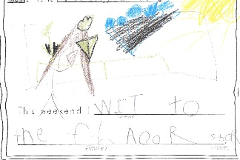  Example: “I went to the flower store.” | 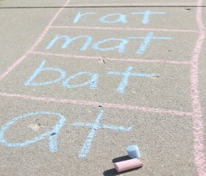  Write some letters or simple words on the sidewalk with chalk. Play hopscotch or make up your own game using the words you wrote! | Play a card game with a family member or friend. Use your flashcards to play a guessing game. Flip over a card. The first person to say the letter name and make the sound wins the card! Take turns flipping the cards and see how many you can guess! | Build sight words using magnetic letters, then write the words using your white board markers.  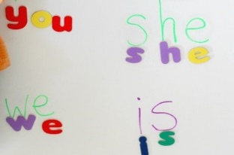  a, and, at, he, in, is, it, like, me, my, play, see, she, that, the, to, was | Make a list of all your favourite ice cream flavours. Stretch out the sounds in each word to do your best spelling!  Examples:  Vnila = Vanilla  Joklit = Chocolate  Strobre = Strawberry  Mun Mst = Moon Mist  Kotin Kande = Cotton Candy
Math  15 minutes a day | Counting  Take your deck of cards and put the numbers in order for each suit. Which colour or suit gets all their numbers to10 first?!  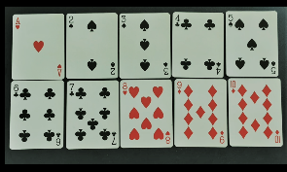  ♦ 1 2 3 4 5 6 7 8 9 10  ♠ 1 2 3 4 5 6 7 8 9 10 | Number Recognition  Play Number BINGO on abcya.com.  -OR-  Using a deck of cards to play Go-Fish with a family member.  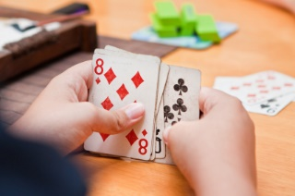 | Subitizing  Listen to the Subitize Rap  -OR-  Collect rocks outside. Put them in a bucket and reach in to grab a handful. Try to subitize as quick as you can!  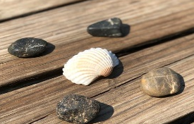 | Patterning  Draw or use Play-Doh to make ice cream patterns. How many different flavours did you create? How many scoops of vanilla? Chocolate? Try to make these patterns:  AB, ABC, AAB, ABB | Measurement  Using the rocks you collected from outside, put them in order from smallest to biggest. Stack them from Biggest to smallest.
Other  15 minutes a day | Movement  Have a Double-Scoop Ice Cream Dance Party!  -OR-  Grab your mini-teachers and have a dance party with the radio on! | Art  Learn how to draw an ice cream cone on ArtHub!  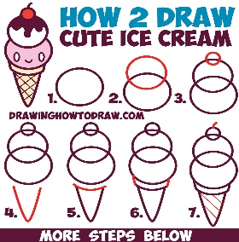 | You & Your World  Watch this video to learn how ice cream is made!  -OR-  Open up an ice cream shop in your home! Use play-doh for scoops of ice cream and have your family visit your shop. Make menus and take their orders. What other responsibilities do you have in the shop? | S.T.E.A.M  Go outside and have a shadow competition! See who can make the biggest shadow and the smallest shadow. How do you change their size? Use items like sticks and rocks. Try to guess which one will have the biggest shadow and why! | 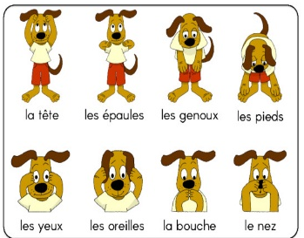  French  Follow along with this French song about parts of our bodies!

