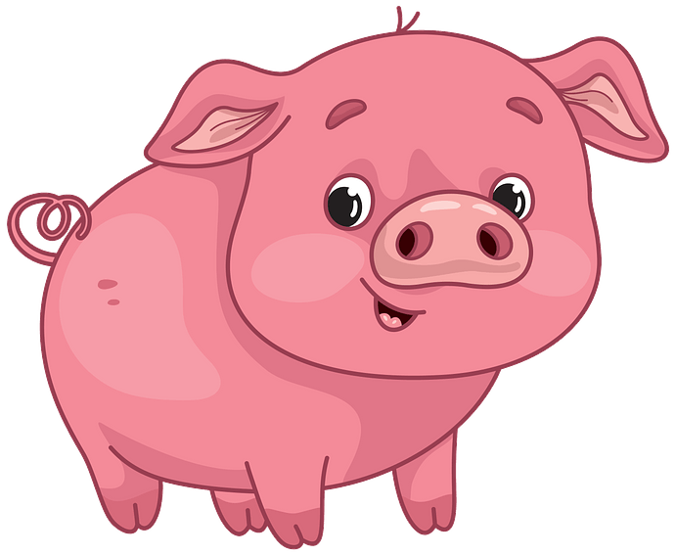Learning Plan for May 4th to 8th
 | Monday | Tuesday | Wednesday | Thursday | Friday
Reading  15 minutes a day | Read a book at home OR Login and read a new book on Raz-Kids.  Read “Mox’s Shop” on starfall and learn more about the short ‘o’ sound. | Read a book at home OR Login and read a new book on Raz-Kids.  Review the short ‘o’ sound by playing the –ot and –og games on starfall. | Read a book at home OR Login and read a new book on Raz-Kids.  Join the TEAMS Meeting with Mrs. Matheson and listen to her read a story. | Read a book at home OR Login and read a new book on Raz-Kids.  Join the TEAMS Meeting with Mrs. Higgins and listen to her read a story. | Read a book at home OR Login and read a new book on Raz-Kids.  Join the TEAMS Meeting with Mrs. Magee and listen to her read a story.
Writing  15 minutes a day | Draw a picture of your favourite farm animal. Write a sentence (or more) about it.  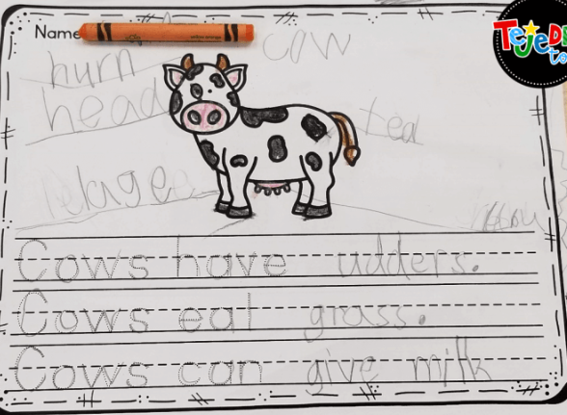  Cows have utters.  Cows eat grass.  Cows can give milk. | Use playdoh to make some letters or sight words.  a, and, at, he, in, is, it, like, me, my, play, see, she, that, the, to, was  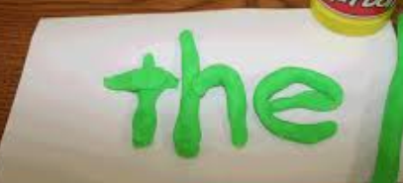 | Go on an ABC scavenger hunt. Find an item in your house that begins with each letter of the alphabet. Record what you find on a piece of paper.  Example:  A- apple  B- ball  C- car  D- doll | Rainbow write your name. First have an adult print your name with pen or black marker. Choose 5 (or more) different colours and trace your name.  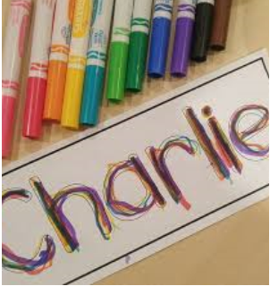 | Make a list of all the farm animals you know. (Encourage your child to stretch out the word slowly and print the sounds they hear).  -hrs (horse)  -chikin (chicken)  -frmr (farmer)
Math  15 minutes a day | Counting  Count the animals on the farm.  -OR-  Count forwards from 0 to 10. Start at 4 and count up to 10.  Count backwards from 10 to 0. Start at 7 and count down to 0. | Comparing Numbers  Watch this video to learn about the terms “more” and “fewer.”  -OR-  Draw 5 cows.  Draw 7 pigs.  Are there more cows or more pigs? Are there fewer cows or fewer pigs? | Shapes  Watch this video and learn about 3D Shapes.  -OR-  Go a shape scavenger hunt around your house. Look for 2D shapes and 3D objects. Can you find a circle or a sphere?  Can you find a square or a cube? Can you find a triangle or a pyramid? | Patterning  Watch this video and learn about patterns.  -OR-  Use different coloured lego pieces (or markers and paper) to make a pattern. Can you make an AB, ABC, or AAB pattern? Can a family member guess what will come next in your pattern? | Number Recognition  Play Number BINGO on abcya.com  -OR-  Practice printing your numbers from 1 to 10. Use a pencil, markers, or paint.
Other  15 minutes a day | Movement & Music  Listen and move to the Chicken Dance on GoNoodle.  -OR-  Sing the song “Old MacDonald had a Farm” and practice making animal sounds. | Art  Learn how to draw a tulip as a special gift for Mom!  -OR-  Make a card for Mother’s Day! Tell someone special in your life how much you care about them and appreciate them. | You & Your World  Learn about what happens on a farm by watching this video.  -OR-  Talk to someone in your family about what you might see on a farm. | S.T.E.A.M  Cut the front of a cereal box (or other cardboard box) into pieces. Try to put the pieces together like a puzzle.  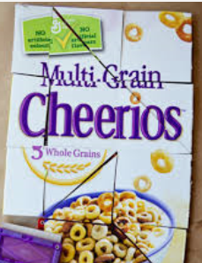 | French  Learn how to say farm animal names in French.  -OR-  Practice saying “My name is ____” in French.  Je m’appelle  Mrs. Matheson.

