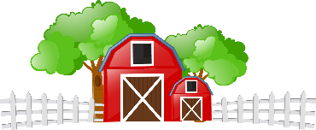
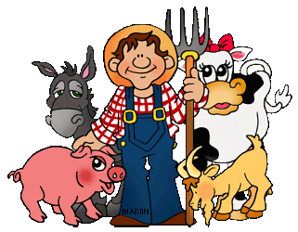
Learning Plan for May 11th – 15th
 | Monday | Tuesday | Wednesday | Thursday | Friday
Reading  15 minutes a day | Read a book at home OR Login and read a new book on Raz-Kids.  Read “Gus the Duck” on Starfall and learn more about the short ‘u’ sound. | Read a book at home OR Login and read a new book on Raz-Kids.  Review the short ‘u’ sound by playing the  –ug game on Starfall. | Read a book at home OR Login and read a new book on Raz-Kids.  Join the TEAMS Meeting with Mrs. Matheson and listen to her read a story. | Read a book at home OR Login and read a new book on Raz-Kids.  Join the TEAMS Meeting with Mrs. Higgins and listen to her read a story. | Read a book at home OR Login and read a new book on Raz-Kids.  Join the TEAMS Meeting with Mrs. Magee and listen to her read a story.
Writing  15 minutes a day | 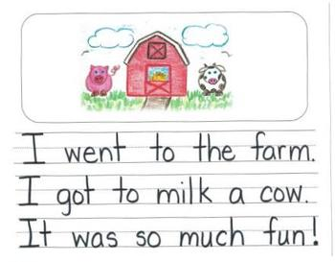  Watch the Farm Field Trip video. Imagine what you might see if you went to a farm. Draw and Write about your imaginary farm adventure! | Rainbow write letters, numbers, names,  or sight words!  a, and, at, he, in, is, it, like, me, my, play, see, she, that, the, to, was  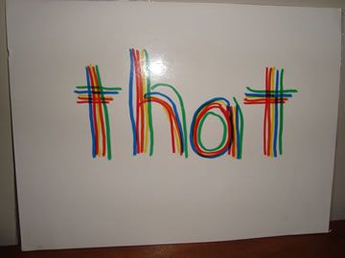 | Draw some different farm animals. What sounds do they make? Write the sound they make beside them.  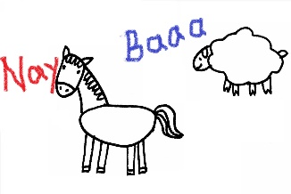 | 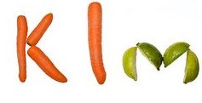  Play with your food! Use some vegetables to form letters or words you know. | Make a list of all the vegetables you know.  (Encourage your child to stretch out the word slowly and print the sounds they hear).  - carit (carrot)  - letus (lettuce)  - pupkin (pumpkin)
Math  15 minutes a day | Counting  Watch this video and help the farmer count the farm animals in his fields.  -OR-  Use your mini teachers to play a racing game. Roll the dice for each teacher and make them take that many steps towards the finish line. | Comparing Numbers  Help Molly the Unicorn with her More  or Less Quest.  -OR-  Draw 3 carrots.  Draw 6 tomatoes.  Are there more carrots or more tomatoes? Are there fewer carrots or fewer tomatoes? | Shapes  Match the 3D Shapes!  -OR-  Go on a shape scavenger hunt around your house with your mini teachers. Can they find 3 things that roll? Can they find 5 things that stack? 2 things that slide? | Patterning  Help these farm animals create patterns!  -OR-  Play with your food! Make a pattern using 2 or 3 different foods. Can you make an AB, ABC, or AAB pattern? | Number Recognition  See what kind of numbers you can find on the farm.  -OR-  Make numbers out of Play-doh or write them with crayons. Try to make the higher numbers bigger and the lower numbers tiny.  0 1 2 3 4 5 6 7 8 9 10
Other  15 minutes a day | Movement & Music  Stretch and breathe with ‘On the Farm’ Yoga  -OR-  Turn on the radio and have a dance party with your mini teachers! Try some farm animal dance moves… flap like a chicken and roll like a pig! | Art  Learn how to draw a farm animal barn.  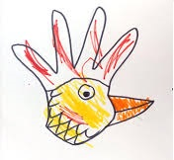  -OR-  Trace your hand and turn it into an animal! | You & Your World  Learn about what farmers do. Would you like to work on a farm?  -OR-  Talk to someone in your family about what you want to be when you grow up. | S.T.E.A.M  Make a house for your mini teachers using paper, blocks or cardboard. Don’t forget to add furniture, windows, doors, and decorations! | French  Learn how to say the names of vegetables in French.  -OR-  Practice saying ‘Thank you’ in French when your family gives you dinner or helps you with something.  “Merci!”

