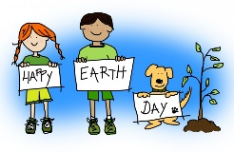
Learning Plan for April 20th - 24th

 | Monday | Tuesday | Wednesday | Thursday | Friday
Reading  15 minutes a day | Read a book at home OR Login and read a new book on Raz-Kids.  Listen to a story under the Kinder Readers tab of our website. | Read a book at home OR Login and read a new book on Raz-Kids.  Read “Peg the Hen” on Starfall. Try to stretch out all of the short ‘e’ words. | Happy Earth Day!  Listen to the Earth Day story under the Kinder Readers tab of our website. | Read a book at home OR Login and read a new book on Raz-Kids.  Review the short ‘e’ sound on Starfall or by brainstorming words that start with “e.” | Read a book at home OR Login and read a new book on Raz-Kids.  Listen to a story under the Kinder Readers tab of our website.
Writing  15 minutes a day | Write about the weather outside today. Add lots of colourful details to your picture and try to write a sentence.  Example:  “It is raining outside.”  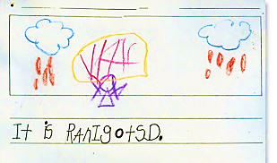 | Use sticks to write your name and other letters/words you know. You can write them in the dirt, or build the letters using the sticks! Can you make any letters using rocks?  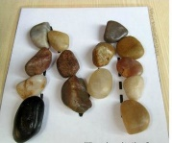 | Draw + label a picture of something you found outside in nature. Take a picture and send it to one of your teachers so we can see your hard work!  Mrs. Matheson:  gina.matheson2@nbed.nb.ca  Mrs. Magee:  rhonda.magee@nbed.nb.ca  Mrs. Higgins:  ellen.higgins@nbed.nb.ca | Practice printing some sight words or letters on paper. Below is a list of some of our words:  a, and, at, he, in, is, it, like, me, my, play, see, she, that, the, to, was | Make a list of things you see outside.  (Encourage your child to stretch out the word slowly and print the sounds they hear).  Example:  - tre (tree)  - flawr (flower)  - bloo ski (blue sky)
Math  15 minutes a day | Counting Game:  Count the spots on the Ladybugs!  OR  Count how many windows you have in your house! How many doors? Cupboards? | Comparing Numbers  Guess if there is More or Fewer of each bug!  OR  Have a family member pick a number between 1 -10. Name a number that is More & a number that is Fewer than their number. | Scavenger Hunt  Do a scavenger hunt outside and count how many of each item you can find.  Can you find 3 bugs?  A circle shape?  4 different rocks?  5 different colours? | Eye-Spy Numbers  Find your animal friends and their numbers!  OR  What numbers can you find around your house?  (on electronics, clocks, flyers, toys etc.) | Counting Game  Count how many fish you see!  OR  Count how many steps it takes you to get from your bed to your door? How many hops? How many tip-toes?
Other  15 minutes a day | Movement & Music  Complete a workout on GoNoodle  OR  Turn the radio on and have a dance party in your living room with your family! | Art  Learn how to draw the Earth on Art Hub.  OR  Create a sidewalk-chalk masterpiece to make your neighbours smile! | You & Your World  Watch this awesome Earth Day Video!  OR  Talk to your family about what you can do at home to help the environment. Do you Compost? Recycle? | S.T.E.A.M  Learn how seeds grow into plants by watching this video.  OR  Plant some different seeds you find in food you eat and see if they grow! | French  Watch a cartoon in French on Mini TFO.  OR  Practice saying Yes & No in French with your family. (Oui + Non)  Mom - “Do you want a snack?”  Child - “Oui!”

